1. Plotting and Fitting of Binomial Distribution with Graphical Representation

Introduction
The binomial distribution is a discrete probability distribution that models the number of successes in a fixed number of independent trials. Each trial must have only two possible outcomes, typically referred to as success and failure. A common example is flipping a coin multiple times and counting how many times it lands on heads.

Mathematical Formula
The probability of getting exactly k successes in n trials is calculated using the binomial formula:
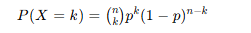
Here, nCk represents combinations, which calculates the number of ways to choose k successes from n trials.

Explanation of Terms
• n: Total number of trials conducted in the experiment.
• k: Number of successful outcomes we are interested in.
• p: Probability of success in a single trial.
• (1 − p): Probability of failure in a single trial.
• P(X = k): The probability of obtaining exactly k successes out of n trials.

Key Characteristics
Mean (Expected Value): The average number of successes expected is given by μ = n × p. This helps predict the center of the distribution.
Variance: The spread of the distribution is measured using σ² = n × p × (1 − p). A higher variance means the data is more spread out.

Excel Implementation
In Excel, binomial probabilities can be calculated using the BINOM.DIST function:
=BINOM.DIST(number_of_successes, number_of_trials, probability_of_success, cumulative)
If cumulative is set to FALSE, Excel returns the exact probability P(X = k). If TRUE, it returns the cumulative probability P(X ≤ k).

Shape of the Distribution
The shape of a binomial distribution depends on the value of p:
• When p = 0.5, the distribution is symmetric, meaning it is evenly balanced around the center.
• When p < 0.5, the distribution is skewed to the right, meaning most values are concentrated on the left.
• When p > 0.5, the distribution is skewed to the left, meaning most values are concentrated on the right.

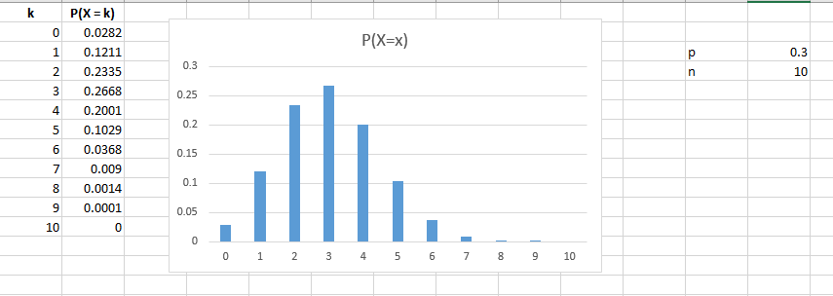
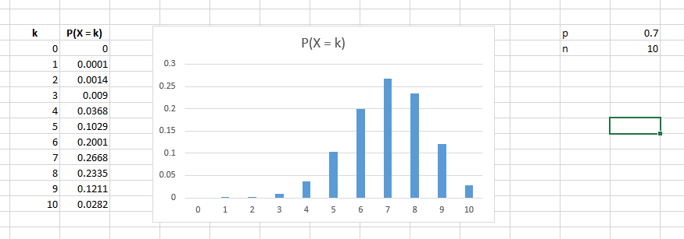
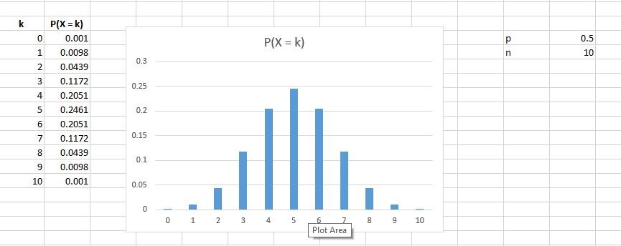

2. Multinomial Distribution & Graphical Representation

Introduction
The multinomial distribution is an extension of the binomial distribution used when each trial can result in more than two possible outcomes instead of just success or failure.
Imagine an experiment where each trial can produce one of k different categories (for example: Red, Green, Blue). Each outcome has its own probability, and all probabilities together must add up to 1.
If we repeat the experiment n times, we can track how many times each outcome occurs. These counts together follow a multinomial distribution.

Mathematical Representation

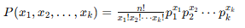

Explanation:
- n → total number of trials
- x₁, x₂, ..., xₖ → number of times each outcome occurs
- p₁, p₂, ..., pₖ → probabilities of each outcome
- Constraint:
  - x1+x2+...+xk=nx₁ + x₂ + ... + xₖ = nx1​+x2​+...+xk​=n
  - p1+p2+...+pk=1p₁ + p₂ + ... + pₖ = 1p1​+p2​+...+pk​=1

Important Concept
Each individual variable (like X₁ or X₂) behaves like a binomial distribution, but all variables together are connected because their total must equal n.

Step 1: Multinomial Coefficient
=MULTINOMIAL(x1, x2, x3)

Step 2: Final Probability
=MULTINOMIAL(x1,x2,x3) * (p1^x1) * (p2^x2) * (p3^x3)

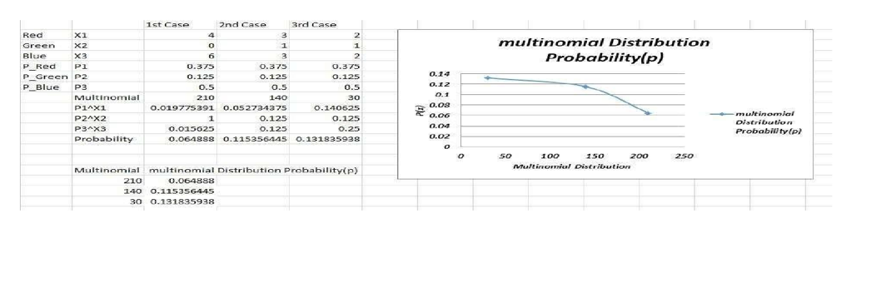

3. Poisson Distribution & Graphical Representation

Introduction
The Poisson distribution is a discrete probability model used to estimate how many times an event is likely to occur within a fixed interval of time, distance, or space.
It is especially useful when:
- Events occur randomly
- Events happen independently
- The average occurrence rate remains constant
This distribution is controlled by a single parameter called λ (lambda), which represents the average number of occurrences in the given interval.

Mathematical Formula
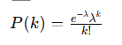

🔹 Explanation of Terms
- P(k) → probability of observing exactly k events
- λ (lambda) → average number of occurrences
- k → number of events (0, 1, 2, …)
- e → constant ≈ 2.718

🔹 Key Properties
- Mean (Expected value):
μ = λ
- Variance:
σ² = λ
- Standard Deviation:
σ = √λ

Excel Implementation
To calculate probabilities in Excel:
=POISSON.DIST(k, λ, FALSE)
- k → number of events
- λ → average rate
- FALSE → gives exact probability
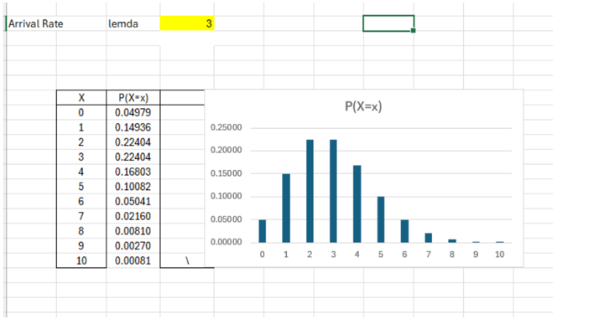

4. Geometric Distribution & Graphical Representation

Introduction
The geometric distribution is a discrete probability distribution that models the number of trials required to achieve the first success in a sequence of independent experiments.
Each trial has only two possible outcomes:
- Success
- Failure
Unlike the binomial distribution, this focuses on when the first success happens, not how many successes occur overall.

Key Idea
We repeat trials until the first success appears. The variable k represents how many failures occur before that first success.

Mathematical Formula
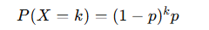

Explanation of Terms
- k → number of failures before the first success (k = 0, 1, 2, …)
- p → probability of success in each trial
- (1 − p) → probability of failure

Important Conditions
For a geometric distribution to apply:
- Each trial must be independent
- Only two outcomes are possible
- Probability of success remains constant

Key Properties
- Mean (Expected value):
μ = (1 − p) / p
- Variance:
σ² = (1 − p) / p²

Excel Implementation
Excel does not have a direct geometric PMF formula in basic form, but you can compute it using:
=(1-p)^k * p
Or using built-in function:
=GEOM.DIST(k+1, p, FALSE)
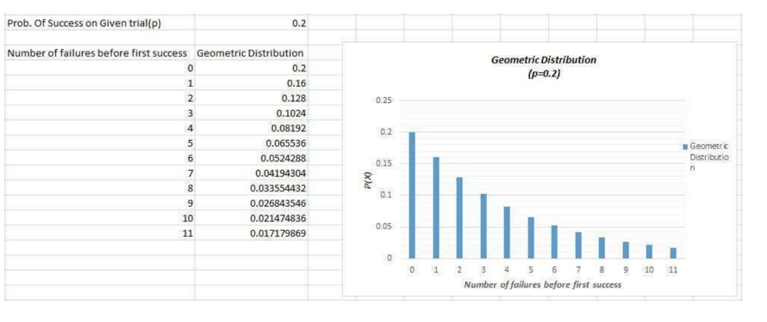

5. Uniform Distribution & Graphical Representation

Introduction
A uniform distribution is a type of probability distribution where all values within a given range are equally likely to occur. Unlike other distributions where some outcomes are more probable, this one assigns the same probability density across the entire interval.
It is often called a rectangular distribution because its graph forms a flat horizontal line.

Key Concept
The distribution is defined over an interval:
- a → minimum value
- b → maximum value
Any value between a and b has equal likelihood.

Mathematical Formula
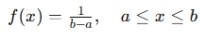

Additional Properties
- Mean (Average):
μ = (a + b) / 2
- Variance:
σ² = (b − a)² / 12

Probability Over an Interval

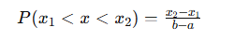

Excel Implementation
You can calculate probability using:
=(x2 - x1) / (b - a)

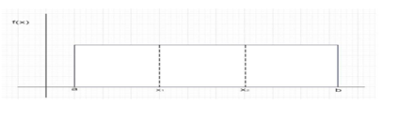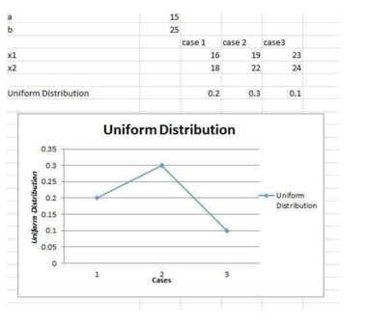

6. Exponential Distribution & Graphical Representation

Introduction
The exponential distribution is a continuous probability distribution used to model the waiting time until a specific event occurs. It is commonly applied when events happen randomly but at a constant average rate.
Unlike discrete distributions, this one deals with time or continuous measurements, meaning the variable can take any positive value.

Key Idea
It answers questions like:
- How long until the next customer arrives?
- How long will a machine run before failing?
- How much time passes between events?
All values are non-negative (x ≥ 0).

Probability Density Function
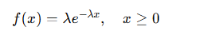

Explanation of Terms
- λ (lambda) → rate of occurrence (average events per unit time)
- x → time or waiting duration
- e → constant ≈ 2.718

Key Properties
- Mean (Expected value):
μ = 1 / λ
- Variance:
σ² = 1 / λ²

Excel Implementation
To compute probability density:
=EXPON.DIST(x, λ, FALSE)
To compute cumulative probability:
=EXPON.DIST(x, λ, TRUE)
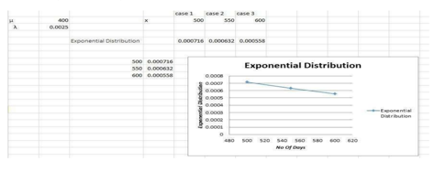

7. Normal Distribution & Graphical Representation

Introduction
The normal distribution is a continuous probability distribution that describes how values are spread around a central average. It is one of the most important distributions in statistics because many real-world measurements naturally follow this pattern.
The graph of a normal distribution forms a bell-shaped curve, where most values cluster around the mean and fewer values appear as we move away from the center.

Probability Density Function
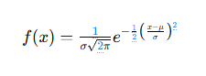

Explanation of Terms
- x → observed value
- μ (mu) → mean (center of the distribution)
- σ (sigma) → standard deviation (spread of data)
- e → constant ≈ 2.718

Key Characteristics
- The curve is perfectly symmetric around the mean
- Mean, median, and mode are equal
- Total area under the curve equals 1
- The curve has a single peak at the mean
- Spread depends on standard deviation:
  - Small σ → narrow curve
  - Large σ → wider curve

Important Insight
- About 68% of values lie within ±1σ
- About 95% lie within ±2σ
- About 99.7% lie within ±3σ
(This is known as the empirical rule)

Excel Implementation

Step 1: Calculate Mean
=AVERAGE(range)

Step 2: Calculate Standard Deviation
=STDEV.S(range)

Step 3: Compute Normal Probability
=NORM.DIST(x, mean, standard_dev, FALSE)
- FALSE → gives probability density
- TRUE → gives cumulative probability
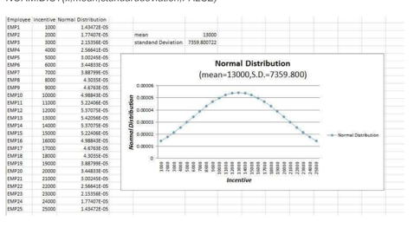

8. Cumulative Distribution Functions (CDF) for Exponential and Normal Distributions

Introduction
A cumulative distribution function (CDF) represents the probability that a random variable takes a value less than or equal to a specific number.
Instead of finding probability at an exact point, the CDF tells us the total probability accumulated up to that point.

Key Idea
- PDF → probability at a specific value
- CDF → probability up to that value

Excel Concept
In Excel, cumulative probability is calculated by setting the last argument to TRUE.

Normal Distribution (CDF)

🔹 Excel Formula
=NORM.DIST(x, mean, standard_dev, TRUE)
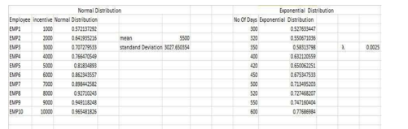

9. Finding Distance Between Two Distributions

Introduction
When comparing two probability distributions, we often want to measure how different they are. One simple and widely used method for this is the Euclidean distance.
It calculates the distance between two sets of values by treating them as points in space.

Concept of Euclidean Distance
The Euclidean distance measures the straight-line distance between two vectors.
If we have two distributions:
- X = (x₁, x₂, …, xₙ)
- Y = (y₁, y₂, …, yₙ)
Then the distance between them is:

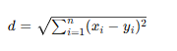

Explanation of Terms
- xᵢ, yᵢ → corresponding values from two distributions
- n → total number of observations
- d → overall distance
👉 Insight:
- Smaller distance → distributions are similar
- Larger distance → distributions are very different

Correct Excel Implementation
The formula shown in your image has an error. The correct Excel approach is:
=SQRT(SUMXMY2(range_X, range_Y))

Explanation:
- SUMXMY2 → computes sum of squared differences
- SQRT → takes square root

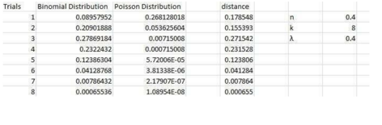
10. Application problems based on the Binomial distribution.
Ques: Antibiotics occasionally cause nausea as a side effect. A major drug company has developed a new antibiotic called Phe-Mycin. The company claims that, at most, 10 percent of all patients treated with Phe-Mycin would experience nausea as a side effect of taking the drug. Suppose that we randomly select n = 4 patients and treat them with Phe-Mycin. Each patient will either experience nausea (which we arbitrarily call a success) or will not experience nausea (a failure). We will assume that p, the true probability that a patient will experience nausea as a side effect, is.10, the maximum value of p claimed by the drug company. Furthermore, it is reasonable to assume that patients' reactions to the drug would be independent of each other. Let x denote the number of patients among the four who will experience nausea. as a side effect. It follows that x is a binomial random variable, which can take on any of the potential values 0, 1, 2, 3, or 4. That is, anywhere between none of the patients and all four of the patients could potentially experience nausea as a side effectSuppose that we wish to investigate whether p, the probability that a patient will experience nausea as a side effect of taking Phe-Mycin, is greater than. 10, the maximum value of p claimed by the drug company. This assessment will be made by assuming, for the sake of argument, that p equals 10, and by using sample information to weigh the evidence against this assumption and in favor of the conclusion that p is greater than .10. Suppose that when a sample of n=4 randomly selected patients is treated with Phe-Mycin, three of the four patients experience nausea. Because the fraction of patients in the sample that experience nausea is 3/4.75, which is far greater than .10, we have some evidence contradicting the assumption that p equals.10.

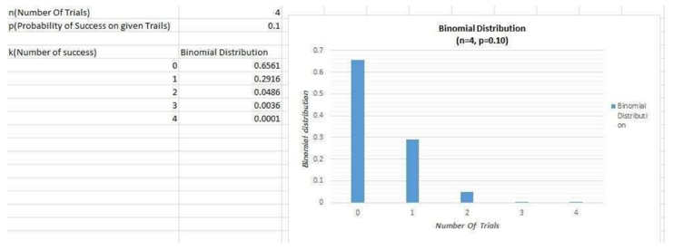
11. Application problems based on the Poisson distribution.
Ques: In a cafe, the customer arrives at a mean rate of 2 per min. Find the probability of arrival of 5 customers in 1 minute using the Poisson distribution formula.
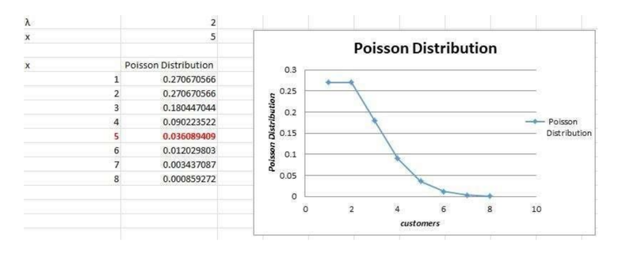
12. Application problems based on the Normal distribution.
Ques: According to the website of the American Association for Justice, ^11 Stella Liebeck of Albuquerque, New Mexico, was severely burned by McDonald's coffee in February 1992. Liebeck, who received third-degree bums over 6 percent of her body, was awarded $160,000 in compensatory damages and $480,000 in punitive damages. A post-verdict investigation revealed that the coffee temperature at the local Albuquerque McDonald's had dropped from about 185 degree F before the trial to about 158 degree after the trial. This case concerns coffee temperatures at a fast-food restaurant. Because of the possibility of future litigation and to possibly improve the coffee's taste, the restaurant wishes to study the temperature of the coffee it serves. To do this, the restaurant personnel measure the temperature of the coffee being dispensed (in degrees Fahrenheit) at a randomly selected time during each of the 24 half-hour periods from 8 a.m. to 7:30 p.m on a given day. This is then repeated on a second day, giving the 48 coffee temperatures in excel..
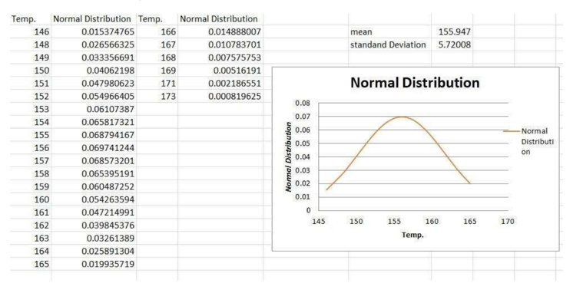

13. Presentation of Bivariate Data Using Scatter Plots and Covariance

Introduction
Bivariate analysis deals with studying the relationship between two variables. In this type of analysis, one variable is often considered independent, while the other depends on it.
The main objective is to understand whether and how these two variables are related to each other.

Methods of Analyzing Bivariate Data
There are three common approaches used to examine relationships between two variables:
- Scatter Plot
- Correlation Coefficient
- Simple Linear Regression (SLR)

Bivariate Frequency Distribution
This refers to organizing data that shows the frequency of two variables together. It helps in understanding how often certain combinations of values occur.
Such analysis is widely used in business and research to study relationships between factors.

Importance in Decision Making
Bivariate analysis is useful in many real-world applications, such as:
- Making business decisions
- Market segmentation
- Risk evaluation
- Resource planning

Covariance
Covariance measures how two variables change together.

Formula:

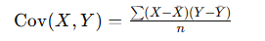

Explanation:
- X and Y → variables
- Xˉ,Yˉ\bar{X}, \bar{Y}Xˉ,Yˉ → mean values
- n → number of observations

🔹 Key Points About Covariance
- It shows the direction of relationship between variables
- Positive value → variables move in the same direction
- Negative value → variables move in opposite directions
- A value near zero → weak or no relationship

Correlation
Correlation provides both strength and direction of the relationship between two variables.

Pearson Correlation Formula:
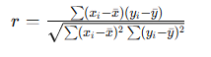

Properties of Correlation
- Value lies between -1 and +1
- +1 → perfect positive relationship
- -1 → perfect negative relationship
- 0 → no relationship
- Not affected by change in measurement scale

Types of Correlation
- Positive Correlation → both variables increase together
- Negative Correlation → one increases while the other decreases
- No Correlation → no clear relationship

Scatter Plot
A scatter plot is a graphical representation where each data point is plotted on a coordinate system using two variables.
- X-axis → independent variable
- Y-axis → dependent variable
It helps visually identify patterns or relationships.

When Scatter Plots Are Useful
- When data is available in pairs
- To observe trends and relationships
- To detect clusters or patterns

Excel Implementation

Covariance:
=COVARIANCE.P(array1, array2)

Correlation:
=CORREL(array1, array2)

Interpretation of Scatter Plot
- Points moving upward → positive correlation
- Points moving downward → negative correlation
- Random spread → no correlation

Conclusion
Bivariate analysis helps in understanding how two variables interact. Tools like covariance, correlation, and scatter plots provide both numerical and visual insights, making them essential for data analysis and decision-making.

14. Calculation of Karl Pearson’s Correlation Coefficient

Introduction
Karl Pearson’s correlation coefficient is a statistical measure used to determine the strength and direction of a linear relationship between two variables.
It helps us understand how closely two variables are related and whether they move together or in opposite directions.

Range of Values
The value of the correlation coefficient (r) always lies between:
- +1 → perfect positive relationship
- −1 → perfect negative relationship
- 0 → no linear relationship

Interpretation
- r = +1 → both variables increase together in perfect proportion
- r = −1 → one variable increases while the other decreases perfectly
- r = 0 → no consistent linear pattern between variables
👉 The closer the value of r is to ±1, the stronger the relationship.

Formula
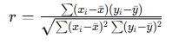

Explanation of Terms
- xᵢ, yᵢ → individual data values
- xˉ,yˉ\bar{x}, \bar{y}xˉ,yˉ​ → mean values of X and Y
- r → correlation coefficient

Steps for Calculation
- Find the mean of both variables (X and Y)
- Subtract the mean from each value
- Multiply the deviations of corresponding values
- Square the deviations for each variable
- Apply the formula to compute r

Example Context
Typically, we are given a dataset of values (X₁, X₂, X₃, …) along with corresponding values (Y₁, Y₂, Y₃, …). The goal is to calculate how strongly these paired values are related.

Excel Implementation
=CORREL(array1, array2)
- array1 → values of X
- array2 → values of Y

Key Points
- Measures only linear relationships
- Does not imply causation
- Not affected by unit changes (scale-independent)
- Useful for identifying trends in data

Conclusion
Karl Pearson’s correlation coefficient is a powerful tool for analyzing relationships between variables. It provides a clear numerical value that summarizes both the strength and direction of the association.
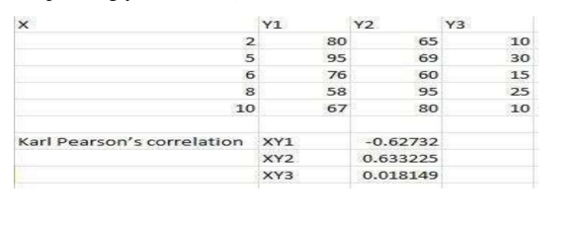

15. Finding Correlation Coefficient for a Bivariate Frequency Distribution

Introduction
A bivariate frequency distribution is a table that shows the frequencies of two variables simultaneously. Instead of listing individual data points, it groups them into classes and records how often each combination occurs.
This type of data presentation allows us to calculate the correlation coefficient directly from grouped data, without needing raw observations.

Key Idea
In this case:
- We are not given individual values
- Instead, we are given frequencies for combinations of X and Y
The goal is to measure the relationship between the two variables using this grouped information.

Approach
To compute the correlation coefficient from a bivariate frequency table:
- Identify class intervals for both variables (X and Y)
- Determine the midpoints of each class
- Multiply frequencies with corresponding midpoints
- Use these values to compute required sums
- Apply the correlation formula

Formula
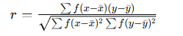

Explanation of Terms
- f → frequency of each cell
- x, y → midpoints of class intervals
- xˉ,yˉ\bar{x}, \bar{y}xˉ,yˉ​ → mean values
- r → correlation coefficient

Important Points
- Frequencies act as weights in calculations
- Midpoints are used instead of raw values
- The method is useful when data is grouped

Excel Implementation
While Excel does not directly support grouped correlation, you can:
- Expand the grouped data into raw format (optional), or
- Use formulas with frequency weighting manually
Basic correlation (if data expanded):
=CORREL(array1, array2)

Practical Example Context
A typical example includes data such as:
- Marks obtained by students (X)
- Age groups or categories (Y)
The table shows how many students fall into each combination of marks and age group. Using this, we calculate how strongly age and marks are related.

Interpretation
- r > 0 → positive relationship
- r < 0 → negative relationship
- r ≈ 0 → weak or no relationship

Conclusion
Bivariate frequency distributions make it possible to analyze relationships even when data is grouped. By incorporating frequencies into calculations, we can still obtain a reliable measure of correlation.
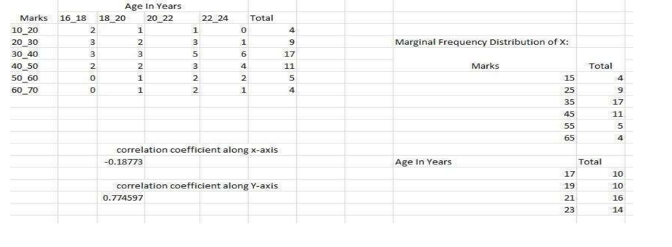

16. Generating Random Numbers from Discrete Distributions (Bernoulli, Binomial, Poisson)

Introduction
Random number generation is useful for simulating real-life scenarios where outcomes are uncertain. In statistics, we can generate random values that follow specific probability distributions such as Bernoulli, Binomial, and Poisson.
Excel provides built-in functions that allow us to easily simulate such random outcomes.

Key Idea
Instead of manually calculating probabilities, we use:
- A random number generator → RAND()
- Distribution functions → to convert random values into meaningful outcomes

🔹 1. Bernoulli Distribution (0 or 1 Outcome)
A Bernoulli trial produces only two outcomes:
- 1 → success
- 0 → failure

Excel Formula:
=IF(RAND()<=p,1,0)

2. Binomial Distribution
The binomial distribution represents the number of successes in multiple trials.

Excel Formula:
=BINOM.INV(n, p, RAND())

Explanation:
- n → number of trials
- p → probability of success
- RAND() → generates a random probability

3. Poisson Distribution
Used to model the number of events occurring in a fixed interval.

Excel Formula:
=POISSON.INV(RAND(), λ)

Explanation:
- λ (lambda) → average rate of occurrence
- RAND() → random probability
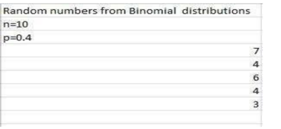

17. Generating Random Numbers from Continuous Distributions (Uniform, Normal)

Introduction
Continuous distributions are used when values can take any number within a range, rather than specific discrete outcomes. Common examples include the Uniform and Normal distributions.
Excel allows us to generate random numbers that follow these distributions using built-in functions.

Key Idea
- RAND() generates a random value between 0 and 1
- This value can be transformed into a desired distribution using appropriate formulas

1. Uniform Distribution
In a uniform distribution, every value within a specified interval has an equal chance of occurring.

Excel Formula:
=a + (b - a) * RAND()

2. Normal Distribution
A normal distribution generates values centered around a mean, forming a bell-shaped pattern.

Excel Formula:
=NORM.INV(RAND(), mean, standard_dev)

Explanation:
- RAND() → provides random probability
- mean → average value
- standard_dev → spread of values
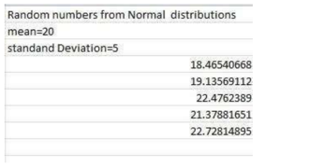

18. Finding Entropy from a Given Data Set

Introduction
Entropy is a measure used in information theory to quantify the uncertainty or randomness in a dataset. It indicates how unpredictable the outcomes of a random variable are.
If the outcomes are highly uncertain, entropy is high. If the outcomes are more predictable, entropy is low.

Key Idea
Consider a discrete random variable X with possible outcomes and their probabilities:
- Each outcome has a probability p(x)
- Entropy combines all these probabilities to measure overall uncertainty

Formula
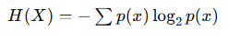

Explanation of Terms
- H(X) → entropy of the variable
- p(x) → probability of each outcome
- log₂ → logarithm base 2

Important Notes
- Base 2 is commonly used → entropy is measured in bits
- If natural log is used → units are nats
- Entropy is always non-negative

Interpretation
- H(X) = 0 → no uncertainty (one outcome is certain)
- Higher H(X) → more randomness
- Maximum entropy occurs when all outcomes are equally likely

Excel Implementation
You can compute entropy in Excel using:
=-(p1*LOG(p1,2) + p2*LOG(p2,2) + ...)

Key Takeaways
- Entropy measures uncertainty in data
- Equal probabilities → maximum entropy
- Useful in:
  - data science
  - machine learning
  - communication systems

Conclusion
Entropy provides a numerical way to describe how unpredictable a dataset is. It plays a crucial role in analyzing probability distributions and understanding information content.
